**Health & Safety Talk**

**Environment**

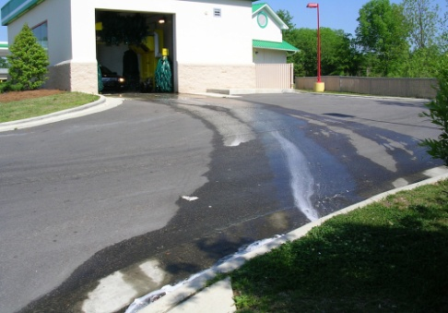

Now more than ever organisations are required to consider their environmental impact in the day to day running of their business.

**What are the risks if we don’t?**

* Potential prosecution from the EPA
* Higher costs for the business
* Damaged business reputation

**What should we do (Some basic steps)?**

* Never tip chemicals down the stormwater drain. The EPA can trace the source of the pollution back to the business.
* Ensure that all chemical spills are cleaned up immediately.
* Make sure car batteries are not left outside, they need to be stored undercover in a bunded area.
* Chemical containers should be placed back in a bunded area or in a location that if a leak occurs the run-off will not reach the stormwater drain.
* Ensure that all wastes are disposed of correctly, this includes recyclable wastes.
* Turn off at the power point all un-used equipment and shut down lights and computer equipment at the close of business daily.

So not only is caring for the environment a legal responsibility it can also significantly cut costs for the business.

**Who is responsible?**

Everyone is responsible for improving their own and their businesses environmental impact.

|  |  |
| --- | --- |
| **Consultation** |  |

**Date of Meeting:**_____________________

**Attendees** (list attendees present)

|  |
| --- |
|  |

**Items Discussed**

|  |
| --- |
|  |

**Action Items**

|  |
| --- |
|  |

**Management Sign Off**

**Name:** _______________________________________

**Sign:** ___________________________________ **Date:** ______________________________